generate
derives
advantage
consume
contaminate

The power plant helps to generate electricity.
Grape juice is derived from fresh grapes.
One advantage to studying hard is earning good grades.
North America consumes a large quantity of oil.
Chemicals will contaminate the fresh water.

(v.)-produce
(v.)-comes from
(n.) –helpful quality
(v.)- to use up
(v.)- poison;pollute

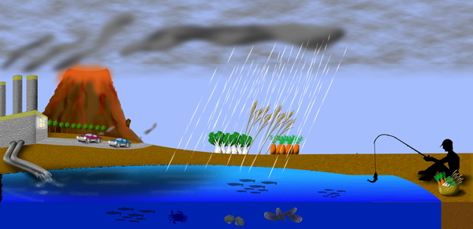
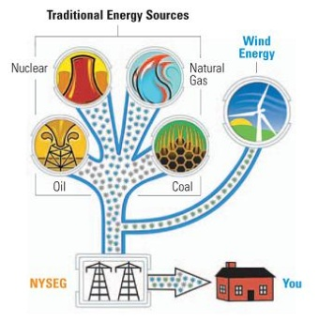

Nuclear power plants _______________electricity. The energy is ________________ from a nuclear reaction that occurs at a nuclear power plant. One ____________ to this type of energy is that it made right here in the United States so it cannot be cut off by another country. Some energy comes from oil. Americans ____________ a large amount of oil for energy production. This can _____________________ our air.

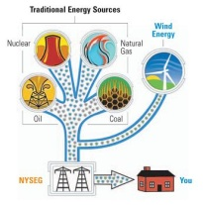

Answer Key
Nuclear power plants generate electricity. The energy is derived from a nuclear reaction that occurs at a nuclear power plant. One advantage to this type of energy is that it is made right here in the United States so it cannot be cut off by another country. Some energy comes from oil. Americans consume a large amount of oil for energy production. This can contaminate our air.

