obesity
primary
emphasize
restrict
multidimensional

Eating junk food and watching TV all day can lead to obesity.
The primary focus of a child should be eating right and getting exercise.
Teachers must emphasize how important it is to exercise.
Schools are trying to restrict students from eating junk food.
Eating too much junk food can cause multidimensional health issues.

(n.)-state of being extremely overweight
(adj.)-most important; most influential
(v.) –show the importance of
(v.)- keep within limits
(adj.)- having many different sides or characteristics

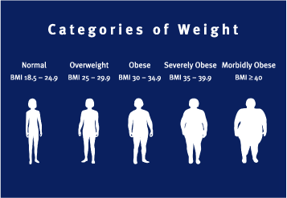

The health teachers want to fight childhood
______________ by helping schools to ____________the amount of junk food eaten by young children across the country. The ______________ concern of these health teachers is to ________________ the importance of eating healthy because of the _____________________ issues that can come from eating unhealthy foods.

Answer Key
The health teachers want to fight childhood obesity by helping schools to restrict junk food eaten by young children across the country. The primary concern of these health teachers is to emphasize the importance of eating healthy because of the multidimensional issues that can come from eating unhealthy foods.

