embryo
paralyzed
theory
investigate
obtain

The embryo began to form in the mother’s womb.
John was paralyzed when the bomb hit his leg.
The scientist came up with a new theory and shared it with the school.
The scientist wanted to investigate the evidence to prove his theory.
The scientist had to obtain data to prove his theory.

(n.)-new organism in a mother’s womb
(adj.)-unable to move
(n.) –an explanation for a set of related facts
(v.)- trying to learn about
(v.)- to get

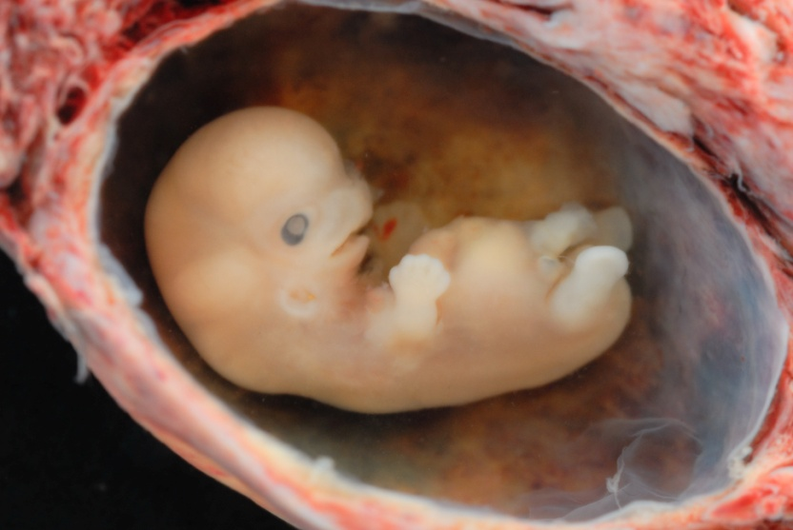
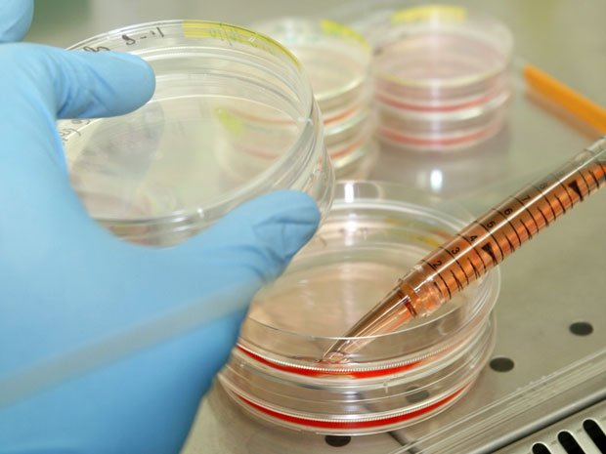
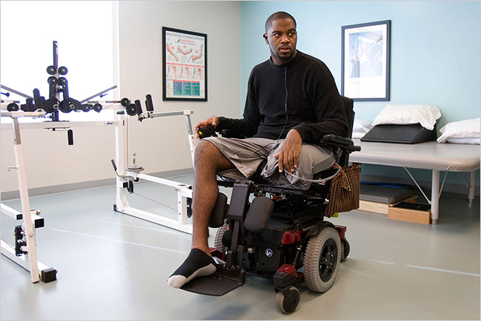

John hurt his leg while surfing and he became __________________. Doctors are hoping to help him by using research from ______________. A team of scientists is going to ________________ a new _______________ in order to ______________important information that could lead to a new life for John.
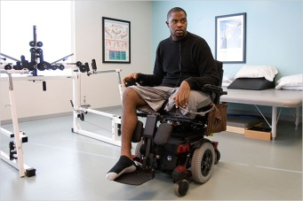

Answer Key
John hurt his leg while surfing and he became paralyzed. Doctors are hoping to help him by using research from embryos. A team of scientists is going to investigate a new theory in order to obtain important information that could lead to a new life for John.

