inequity
resources
adequate
illustrate
disproportionate

We are working to fix the many inequities in the education system.
The teacher used many resources to help the students finish the project.
Since more than half of the school showed up for the movie, we thought it was adequate representation.
The teacher had the students illustrate their new knowledge by teaching the class in groups.
Sadly, a disproportionate number of kids were dropping out of school.

(n.)-lack of equality;unfairness
(n.)-supplies of money or helpful items
(adj.) –as much as necessary
(v.)- demonstrate
(adj.)- too large or too small in comparison to other things

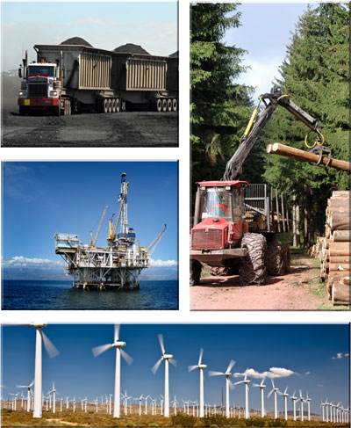
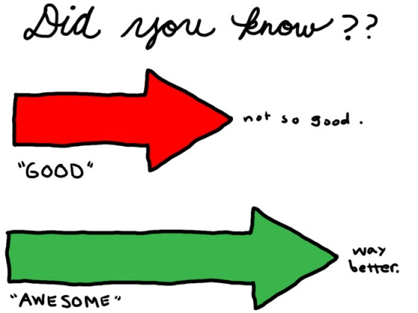

The students wanted to fight against ___________ by finding new ______________ for other students who did not previously have them. Once the students found __________________ resources, they decided to ______________ the need for more money by leading a town hall meeting. The students thought that this meeting would help fix the issue of ____________________resources within our school systems.
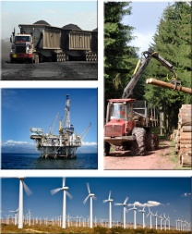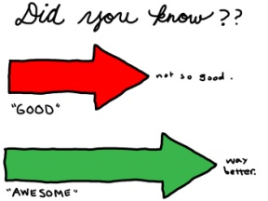

Answer Key
The students wanted to fight against inequity by finding new resources for other students who did not previously have them. Once the students found adequate resources, they decided to illustrate the need for more money by holding a town meeting. The students thought that this meeting would help fix the issue of disproportionate resources within our school system.

