implement
motivate
undertake
incentive
enables

Now that you made your plan to study, you need to implement that plan.
The teacher tried to motivate his students to study for the test.
The teachers will undertake the challenge of putting on a haunted house .
The teacher displays or shows our excellent work to give us incentives to work hard.
Performing well in high school enables you to go to college.

(v.)-to put a plan into action
(v.)-to make someone want to take action
(v.) –to accept as a challenge
(n.)- a reward that leads someone to take action
(v.) make something possible

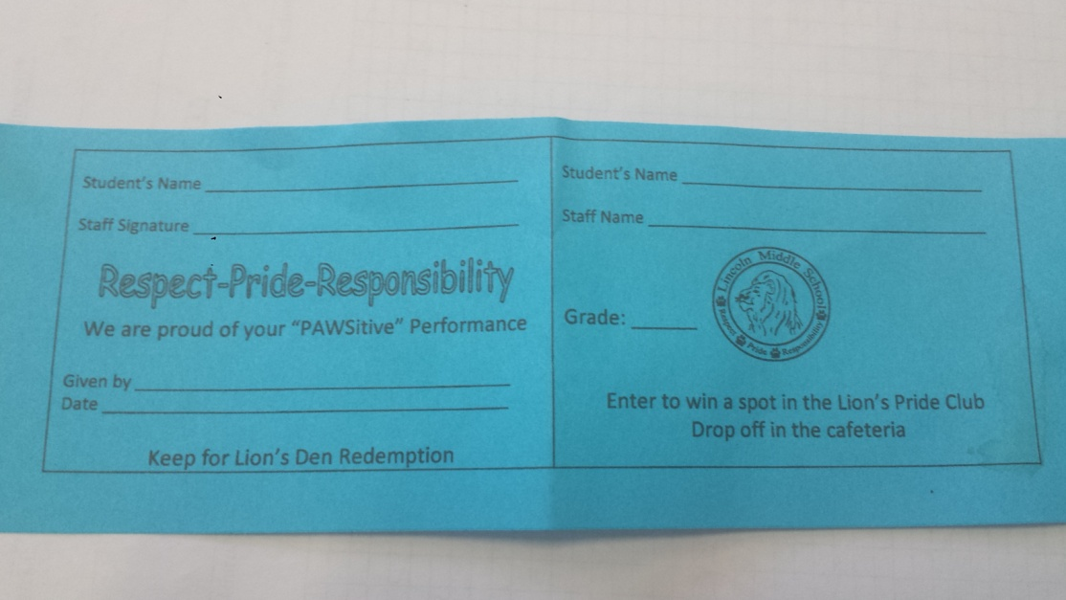
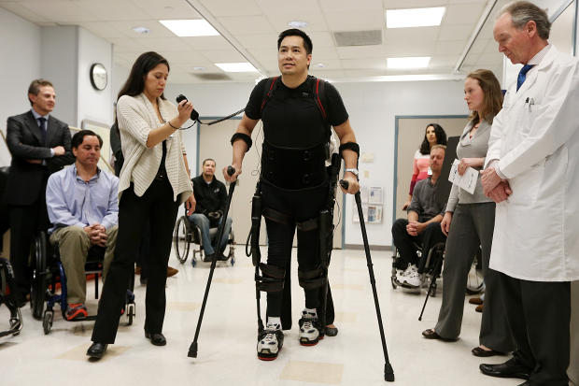

A group of teachers agreed to undertake the challenge of creating a plan to get students to show respect, price and responsibility at Lincoln Middle School. The plan was that students would be given blue tickets when a teacher saw them showing respect, pride and responsibility. These blue tickets would help to motivate students to act appropriately at school. The teachers decided to implement this motivational system. These blue tickets act as an incentive that promotes a better learning environment for all students at Lincoln. The blue tickets enable the students to win prizes or buy items at the Lion’s Den.
A group of teachers agreed to ____________ the challenge of creating a plan to get students to show respect, price and responsibility at Lincoln Middle School. The plan was that students would be given blue tickets when a teacher saw them showing respect, pride and responsibility. These blue tickets would help to ____________ students to act appropriately at school. The teachers decided to ____________ this motivational system. These blue tickets act as an _____________ that promotes a better learning environment for all students at Lincoln. The blue tickets _________________ the students to win prizes or buy items at the Lion’s Den.

