guarantee
contrast
parallel
industry
logical

The air conditioner came with a three year guarantee.
The contrast between grade six students and grade 8 students is enormous.
School communities should parallel real life as much as possible .
I am going to be a nurse and work in the medical industry.
In math we use estimation to make sure our answer is logical.

(v.)-to promise
(n.)-a comparison to show differences
(v.) –to match; to equal
(n.)- general business activity
(adj.) reasonable; based on clear thinking

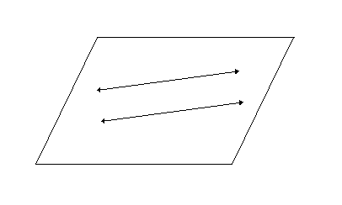

The computer industry designs, makes and programs computers. The people who work there need to be good logical thinkers. They need to be able to use their brains to solve problems. An industry that parallels or is almost the same is the cell phone industry. I guarantee that if you go to college and study computers you will be paid well. In contrast, if you drop out of high school your job opportunities will be limited and your pay will be much less.
The computer ________ designs, makes and programs computers. The people who work there need to be good ______________ thinkers. They need to be able to use their brains to solve problems. An industry that ___________ or is almost the same is the cell phone industry. I ___________ that if you go to college and study computers you will be paid well. In ______________, if you drop out of high school your job opportunities will be limited and your pay will be much less.

