capacity
distribute
method
morality
abstain

The cup does not have the capacity to hold that much water it will overflow.
Please distribute the books to your classmates.
There are several methods for multiplying large numbers together.
Your morality tells you that taking a cell phone out of someone’s locker is wrong.
Please abstain from talking in the library because other people are studying.

(n.)-an ability
(v.)-to give out
(n.) –a way of doing something
(n.)- a sense of right and wrong; values
(v.) to choose not to do something

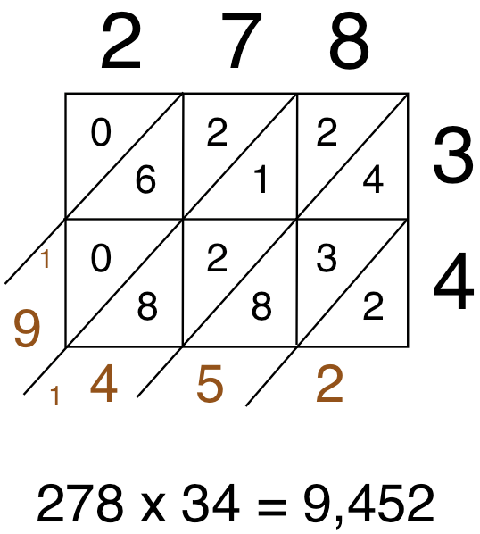
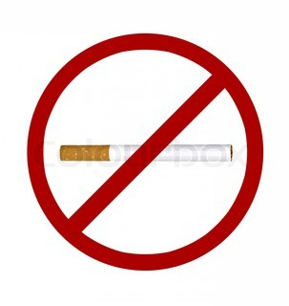

The instructor will distribute the anti-drug materials out to the students in his class. He believes all the students in his class have the capacity or ability to learn how to say no to drugs. He asks his students to abstain from talking to their friends during his teaching time at the board. He is going to show them several methods to tell your friends you don’t want to do drugs. He believes this education is helping the students choose right from wrong and increasing their morality.
The instructor will ____________ the anti-drug materials out to the students in his class. He believes all the students in his class have the _____________ or ability to learn how to say no to drugs. He asks his students to ______________ from talking to their friends during his teaching time at the board. He is going to show them several _____________ to use to tell your friends you don’t want to do drugs. He believes this education is helping the students choose right from wrong and increasing their ________________.

