affirmative
discrimination
aspect
retain
relevant

Affirmative Action is giving groups of people a chance to succeed in American society.
The man showed discrimination when he only chose boys to play the game.
One aspect of science class is learning the scientific method.
Do your homework so you can retain the information you learned in class today.
The conversation you are having needs to be relevant to the topic.

(adj.)-positive
(n.)-prejudice toward a particular group of people
(n.) –a part of something; a characteristic
(v.)- to keep; to hold in place
(adj.) connected

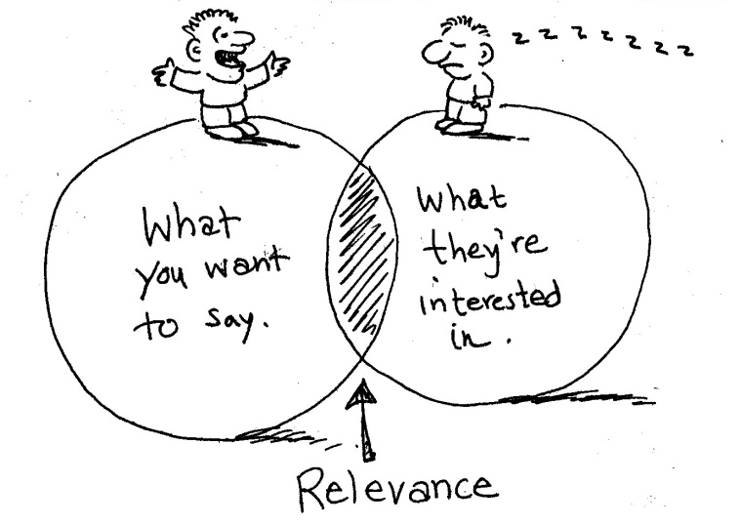

Discrimination against one group of people sometimes happens, for example when a company refuses to hire anyone that is Asian. That is why Affirmative Action was created.

Your teachers teach relevant information to you. You need to do your homework to retain that information. Homework is an important aspect of your learning.
_____________ against one group of people sometimes happens, for example when a company refuses to hire anyone that is Asian. That is why __________________ Action was created.

Your teachers teach _____________ information to you. You need to do your homework to _____________ that information. Homework is an important ______________ of your learning.

