Week 2.21
eligible
affect
maintain
prerequisite
previous

Damien was not eligible to play in the basketball game because he was failing math and science.

A student’s grades will affect whether or not they are allowed to play in games.
Bob likes to maintain his garden and flower beds on the weekends.
Kids must be able to write their names; that is a prerequisite for kindergarten.
The previous class of 7th graders earned money to purchase a mural for the school.

(adj.) worthy of being chosen
(v.) to make a change in something
(v) – to keep in good condition; preserve
(n.) – a requirement that has to be met beforehand
(adj.) –happening before something else
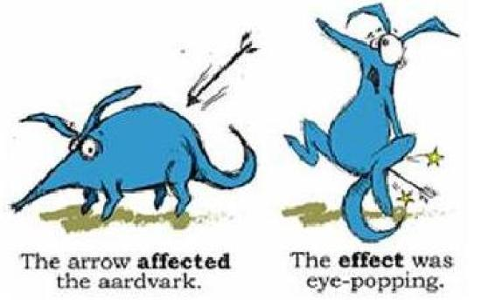
Use these to paste onto their worksheets under the “notes” section.
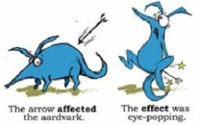

Name:______________________________________________________
Word Generation Unit 22

Students who meet specific behavioral requirements are _____________ to go on the field trip to Six Flags. Getting suspended could _________whether or not they are allowed to attend. Students must ______________ appropriate behavior for the entire month of May. Passing all classes is another __________________ for field trip attendance. Any students who were excluded from _____________ trips have a clean slate so they can earn the trip to Six Flags.

Unit 21 Answer Key
The alien invasion happened at the school. It consisted of three aliens in a space ship. They used corporal punishment to make the student follow their directions. The school was no longer secure. The aliens read the students memories to invade their privacy and then returned to their planet.

