Week 2.21
privacy
invasion
consists
secure
corporal

The doctor spoke softly to protect the patient’s privacy.

Happiness does not consist in how man possessions you own.
The alien invasion happened on June 24, 2014.
Please secure your hat and sunglasses before you go on the rollercoaster.
Teachers used to paddle students as a form of corporal punishment in school.

(n.) not to be seen or heard by other people
(adj.) safe
(v) - to be based on or to depend on something
(adj.) –related to the body
(n) –to take control by force

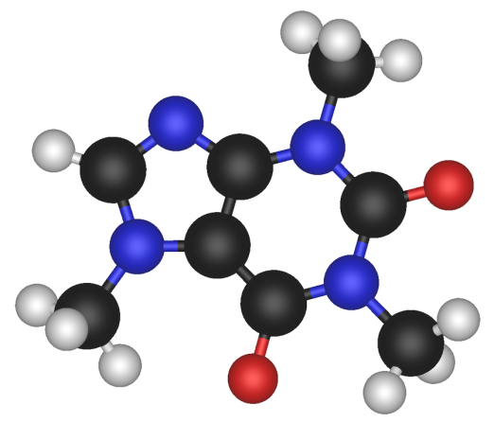
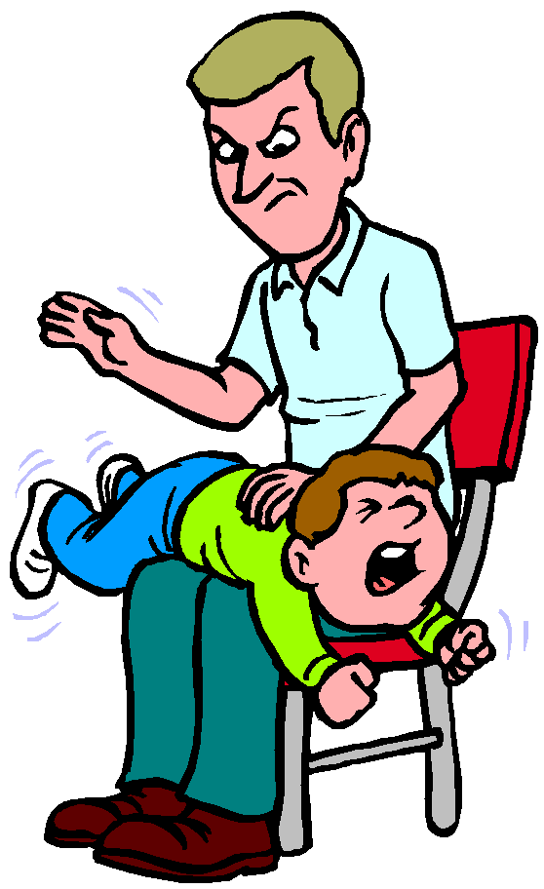
Use these to paste onto their worksheets under the “notes” section.
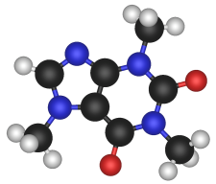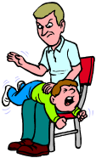

Name:______________________________________________________
Word Generation Unit 21
The alien happened at the school.
It (ed) of three aliens in a space ship.
They used punishment to make the
students follow their directions. The school was no
longer _______________. The aliens read the students
memories to invade their and then
returned to their planet.

Unit 21 Answer Key
The alien invasion happened at the school. It consisted of three aliens in a space ship. They used corporal punishment to make the student follow their directions. The school was no longer secure. The aliens read the students memories to invade their privacy and then returned to their planet.

