standardized
assess
criteria
correspond
formulate

PSSAs are a standardized test for Pennsylvania students.
The math PSSAs assess a student ability to solve all types of math problems.
A question some people raise is should passing the PSSAs be a criteria for being promoted to the next grade.
The information you learn in your classes should correspond with the test.
In math you need to learn to formulate solutions to problems.

(adj.)-the same for everyone
(v.)-judge the quality of; evaluate
(n.) –standards of rules used to make a decision
(v.)- match
(v.) invent by thinking about

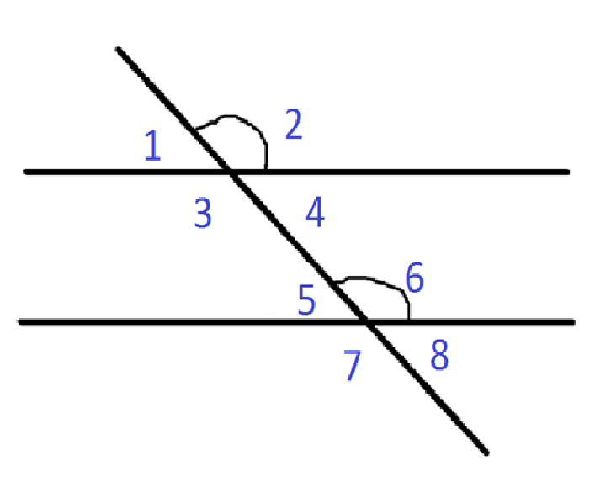

All students who take Algebra 1 need to take the standardized test called the Keystones. Keystones will be used as criteria for graduating from high school. The Keystones Algebra test assesses a student’s knowledge in algebra. In algebra you need to learn to formulate or create equations to solve math problems. The material you learn in your algebra class will correspond with the material that is tested on the test. So, pay attention in math class!
All students who take Algebra 1 need to take the ___________ test called the Keystones. Keystones will be used as ____________ for graduating from high school. The Keystones Algebra test ___________ a student’s knowledge in algebra. In algebra you need to learn to ______________ or create equations to solve math problems. The material you learn in your algebra class will _____________ with the material that istested on the test. So, pay attention in math class!

