Concept
Creationism
Design
Evolve
Perspective

What was the narrator’s perspective in the story?
I designed the new playground for the school.
Automobiles have evolved over the past 30 years.
We learned about the debate between creationism and evolution in science class.
Algebra is a difficult concept for younger students to understand.

(noun) an idea
(noun) a belief that the world was made by an intelligent force
(noun) a plan
(verb) to change over time
(noun) a point of view

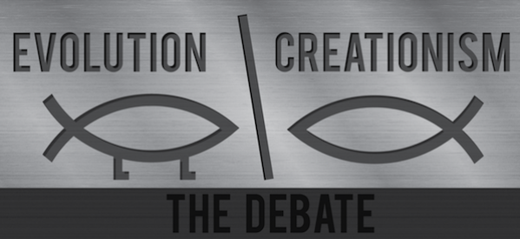
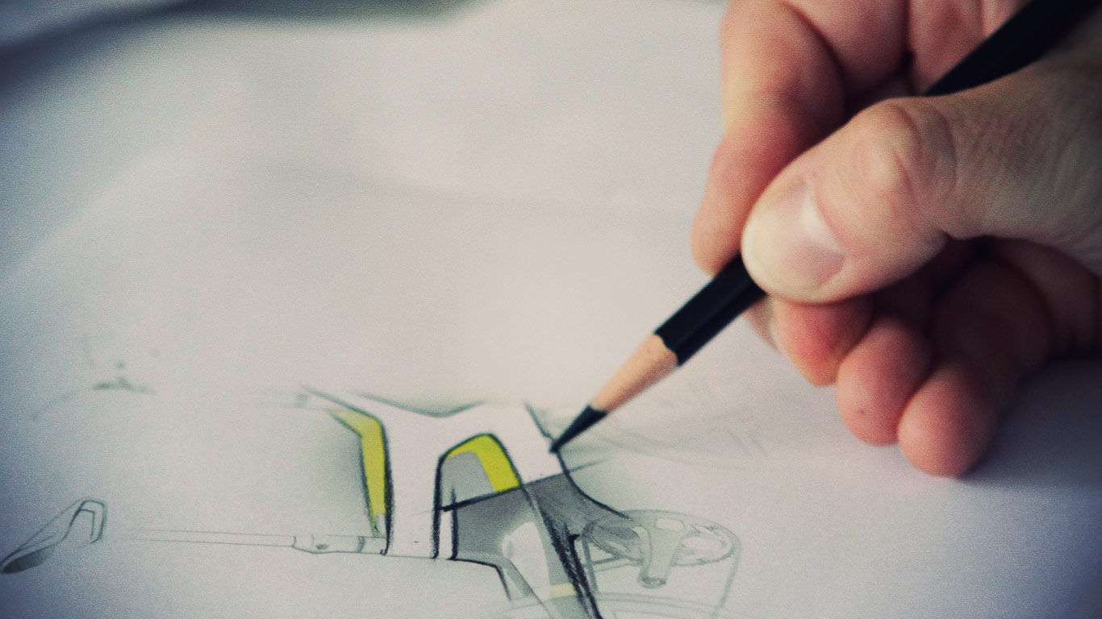
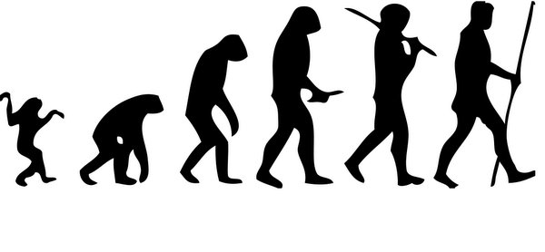
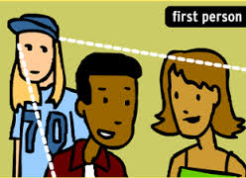
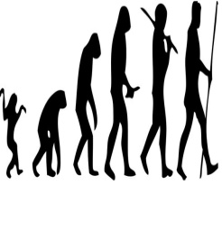

Answer Key:
Today in class, our teacher introduced a new concept to us. She explained to us that some people believe in creationism, which is the idea that higher power created the world and all things in it. Many people believe that an intelligent force must have designed such a complex world. Bobby shouted out, “Well my father’s perspective on the world is different!” He continued to suggest that humans have evolved over thousands of years from monkeys!

Concept Creationism Evolve Design Perspective
Today in class, our teacher introduced a new to us. She explained to us that some people believe in , which is the idea that higher power created the world and all things in it. Many people believe that an intelligent force must have such a complex world. Bobby shouted out, “Well my father’s
on the world is different!” He continued to suggest that humans have over thousands of years from monkeys!

