rating
ban
interact
occur
complex

My mom would only let us see movies that had a rating of G or PG.
The students decided to ban all screaming in the hall.
I interact with my brother and sisters by reading them a book every night.
How often does violence occur in the movie?
The problem was very complex; I couldn’t figure it out on my own.

(noun) a classification, an ordering
(verb) to forbid
(verb) to communicate, to have social contact with
(verb) to happen
(adjective) complicated; of many parts

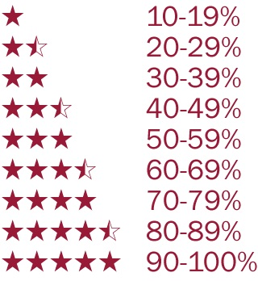
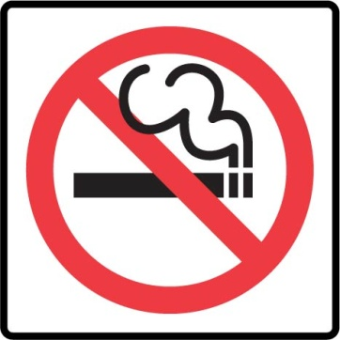
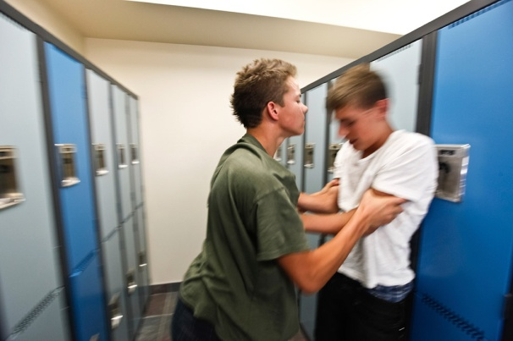
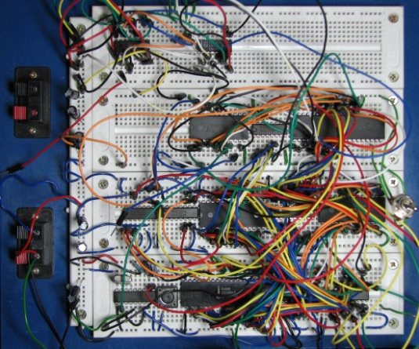
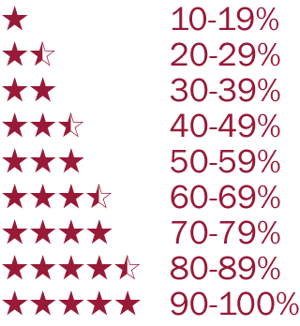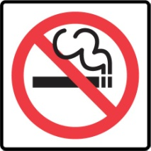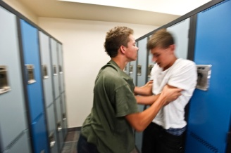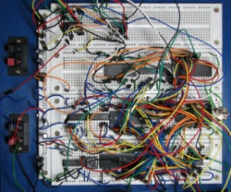

Answer Key:
It was a surprise to us, but our school put a ban on talking to each other at school! How could this occur! The school said their reasons for doing it were complex and we wouldn’t understand. We are worried about how we will be able to interact in class and learn from one another if we cannot speak. We are going to get together and do a survey of the students and teachers to see what rating they would give to the importance of being able to talk in school. My guess is they will all rate it a 10!

rating | ban | interact | occur | complex
It was a surprise to us, but our school put a _______ on talking to each other at school! How could this _______! The school said their reasons for doing it were _______ and we wouldn’t understand. We are worried about how we will be able to _______ in class and learn from one another if we cannot speak. We are going to get together and do a survey of the students and teachers to see what _______ they would give to the importance of being able to talk in school. My guess is they will all rate it a 10!

