economic
multicultural
attribute
facilitate
distinct

We have a multicultural school.
The United States is going through hard economic times right now.
One attribute that I like about our school is that we have great students.
In Europe, students are required to take two distinct foreign languages in school.
How can schools facilitate opportunities for learning languages?

(adj.) related to more than one culture
(adj.)- financial, related to money
(v.) – to make easy or possible
(adj.)- different
(n.)- skill, feature

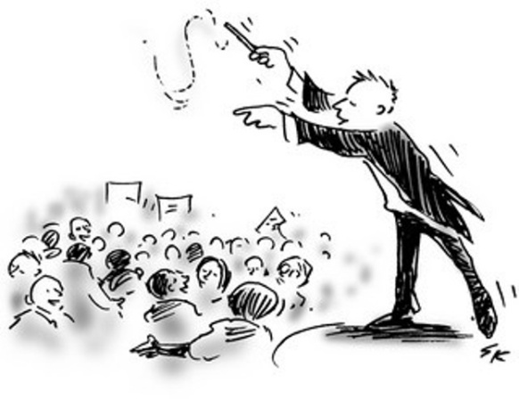
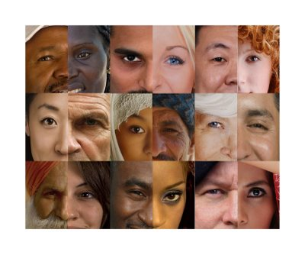
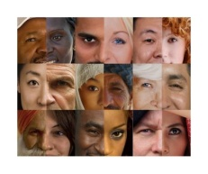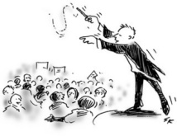

economic | multicultural | attribute | facilitate | distinct
In order for Park City to ____________ great sales they need to research the community around them. If research shows that there are ____________ shoppers they may need to have more ____________ advertisements. The advertisements should focus on different ____________ ____________.

Answer Key:
In order for Park City to facilitate great sales they need to research the community around them. If research shows that there are multicultural shoppers they may need to have more distinct advertisements. The advertisements should focus on different economic attributes.

