prevention
critical
pursue
alter
approach

Some of my friends are critical of my new haircut.
You have the right to pursue your own happiness.
I had to alter my plans because of the weather.
She said her approach was to help save lives, not end them.
The right treatment could be all that is needed for prevention of pain.

(n.)-avoidance
(adj.) against, not supporting
(v.) – to follow; to engage in
(v.)- to change
(n.) method

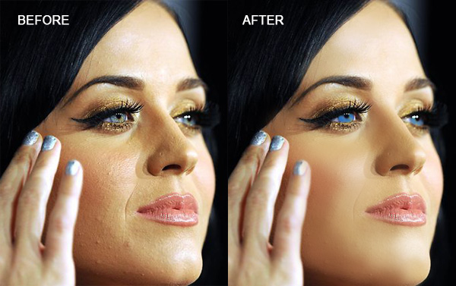
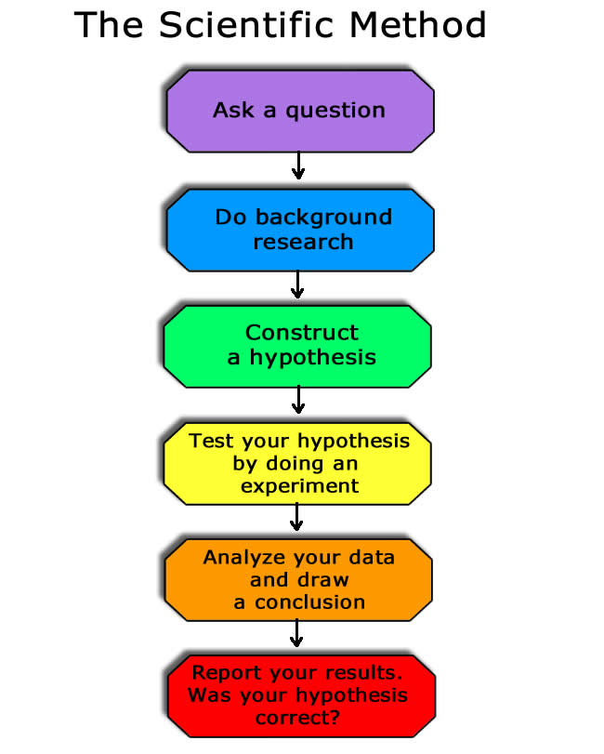

prevention | critical | pursue | alter | approach
It is _____________during your middle school years that you become comfortable with your outward appearance. Self esteem will enhance the _____________ of bullying. When you reach the high school peers will pressure you to _____________your appearance to fit into different groups of friends. Remember that there is always a different _____________. You are always able to _____________ your own friends and find people that will like you for who you are not just how you look.

Answer Key:
It is critical during your middle school years that you become comfortable with your outward appearance. Self esteem will enhance the prevention of bullying. When you reach the high school peers will pressure you to alter your appearance to fit into different groups of friends. Remember that there is always a different approach. You are always able to pursue your own friends and find people that will like you for who you are not just how you look.

