specify
establish
cohesive
constrain
xenophobia

The US does not specify want language is to be used by the government.
Some people want to establish English as the official language of the US.
Some people think having English as the official language will make the country more cohesive.
Use of a language other than English in a public resource like a hospital would be constrained by law.
Sadly, some people have xenophobia which is difficult for immigrants trying to make a living.

(v.)-to clearly define
(v.)-to cause to be recognized and accepted
(adj.) –unified
(v.)- to hold back
(n.)- a fear of foreign people

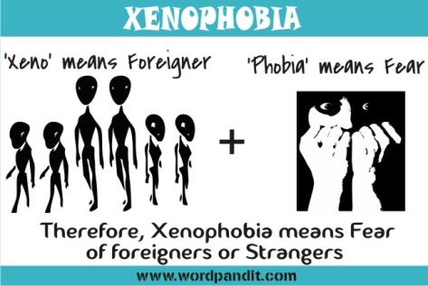

Currently, the US does not _____________what languages can be used by the government. Some people think using English only will make the nation more _____________. They think if they ______________English as the official language, we will become more united. However, this is against the foundation of US principles. Today, using other languages in schools is _____________ by law. Hopefully, some day people will overcome their _______________ and reach out to people from foreign countries.

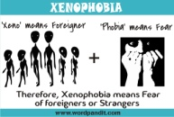

Answer Key
Currently, the US does not specify what languages can be used by the government. Some people think using English only will make the nation more cohesive. They think if they establish English as the official language, we will become more united. However, this is against the foundation of US principles. Today, using other languages in schools is constrained by law. Hopefully, someday people will overcome their xenophobia and reach out to people from foreign countries.

