The Spanish Classroom Project: 2014-15

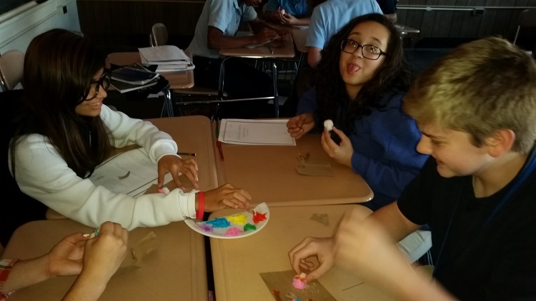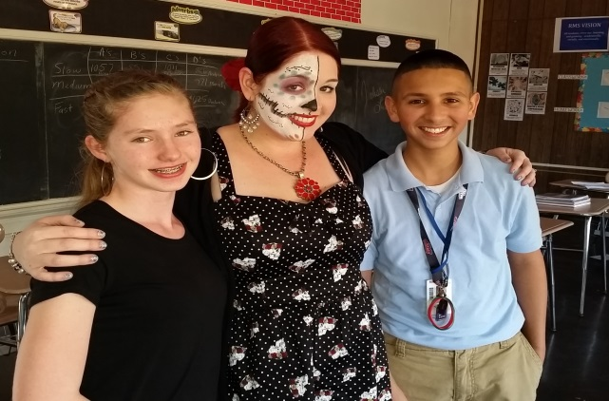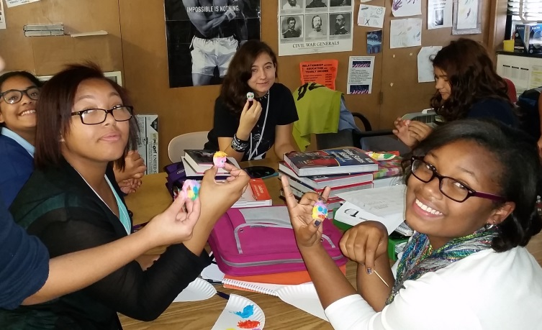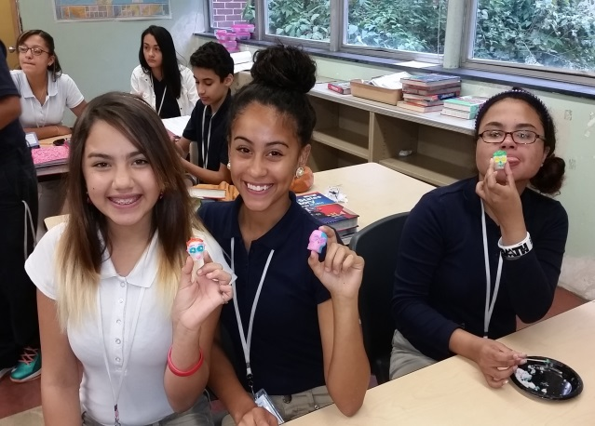
Project Goals:
Students will engage in discussions with other students in the project about, school, hobbies, favorite activities, etc.
Students will learn to respect and appreciate the opinions, cultures and customs of others.
Students will be able to see the differences and similarities between themselves and others.
Students will directly apply concepts and vocabulary learned in the classroom to communicate outside of the classroom.
Standards Alignment: Common Core Standards for Listening and Speaking

Engage effectively in a range of collaborative discussions (one-on-one, in groups, and teacher-led) with diverse partners on age appropriate topics, building on others’ ideas and expressing their own clearly
Focus Questions:

- ¿Cómo eres?
- ¿Quién eres?
- ¿Qué te gusta hacer?
- ¿Cómo es tu escuela?
- ¿Como es tu familia?
- ¿Qué haces durante la semana?
Duration: November - May
Targeted Grade Levels/Age Groups: Grade 8

Prerequisites: Students will need to have an Edmodo account and be somewhat familiar with the correct way to post in a group. They also need a device for taking pictures to upload to Edmodo. Some familiarity with Web 2.0 tools like Animoto, Voicethread, iMovie or other video/photo sharing tools would be helpful
How This Project Works:
Students will use Edmodo to communicate with the other students in their group. Edmodo is a social network that allows students and teachers to create groups that are closed to the public. Once a teacher has signed their class up, I will link them will 3 other classrooms from different regions of the world. Students will be placed into small groups on Edmodo that consist of 2-3 students from each school. In those small groups, the children will answer weekly discussion questions to share information about themselves and ask questions of their teammates to learn more about them. At the end of the project, the students will create a final "Eye Opener" project. What was an interesting thing or eye opener that you learned as a result of your participation in this project? Students may use any medium they choose for this - Voicethread, Animoto, iMove, Glogster, etc. Teachers may choose from the following: individual project, partner or team projects, or one project from the whole class (ie one Voicethread or Slideshare that the whole class contributes to). Final projects will be posted to a wiki so all project participants can view them. Our final celebration activities will include read time meet ups (Skype or Google Hangouts) if time zone permits.
Required Inputs:
- Teacher will post the topics/guiding questions to their group
- Students will write posts in Edmodo to answer the posted questions.
- Teacher will moderate students in the group
- It would also be great if students could share photos (that they took themselves) to go with some of the topics
- Creation of a final "Eye Opener" project

Guidelines:
1. Students will use proper grammar and spelling and not using “texting” language. This is an educational group. Teacher will moderate all comments in the group.
2. Student posts will be prompted and guided. Students can communicate as long it is appropriate communication within the target language.
3. Teacher will post additional discussion questions in which students can collaborate and earn extra credit.

Workflow: (To be updated and worked through)
- Week 1 - Teacher introductions. Get students into Edmodo small groups
- Week 2 - Student introductions in Edmodo small groups
- Week 3 - Discussion topic - What do you do in your free time? Hobbies/Sports/Vacations
- Week 4 - Discussion topic - Favorites - Books/Movies/Music/Games/TV shows
- Week 5 - Discussion topic - Foods - Favorites/local to your area or ethnic background
- Week 6 - Discussion topic - School - Subjects/size/classroom layout/schedule
- Week 7 - Discussion topic - Local Area - Weather/Famous Places/Animals in the wild
- Week 8 - Discussion topic - Holidays you celebrate
- Week 9 - Discussion topic - Share something else about yourself - Future job plans/Funny or embarrassing moment
- Week 10 - 11 -Work on "Eye Opener" projects
- Week 12 - Post "Eye Opener projects to the wiki and set up real time meet ups if possible

