anonymous
underlying
capacity
adequately
harassment

My friend received an anonymous letter in the mail with no return address.
Anger can have various underlying emotions like embarrassment and sadness.
Athletes have the capacity to run many miles without feeling fatigued.
In order to play basketball, I must have adequate grades and stay out of trouble.
Constant naming calling and spreading rumors are considered forms of harassment.
(adj.) not named or identified
(adj.) involved but not revealed or expressed
(noun) ability
(adverb) something done well enough
(noun) the act of verbally/ physically harming or annoying someone


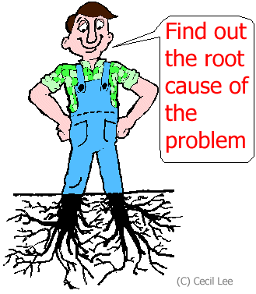


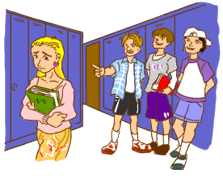
Use these to paste onto their worksheets under the “notes” section.

Name: ______________________________________________________
Word Generation Unit 3.16
Cyberbullying is becoming a major issue in schools across the country and is considered a form of . Cyberbullying occurs online and students can post rumors and negative comments through made up usernames. Students are beginning to feel unsafe at school and cyberbullying is an cause. Schools feel as though they do not have the to monitor cyberbullying because it occurs at home. What do you think?

Word Generation Unit 3.16
Cyberbullying is becoming a major issue in schools across the country and is considered a form of harassment. Cyberbullying occurs online and students can post rumors and negative comments anonymously through made up usernames. Students are beginning to feel unsafe at school and cyberbullying is an underlying cause. Schools feel as though they do not have the capacity to adequately monitor cyberbullying because it occurs at home.

