displace
regime
diminish
stable
estimate

Everyone on the block was displaced because of the fire.
Hitler was the ruler of the evil, Nazi regime.
I worked every day to make my debt diminish.
Even after the earthquake, the house was stable.
I made an estimate of how much the concert would cost.

(verb) to force from home or homeland
(noun) a government in power

(verb) to make smaller or to seem smaller
(adjective) not easily changed
(noun) a rough calculation

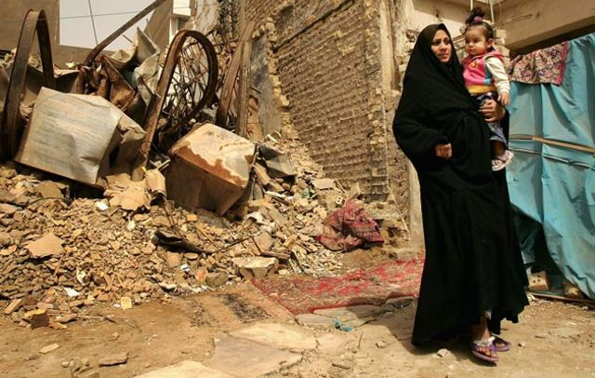
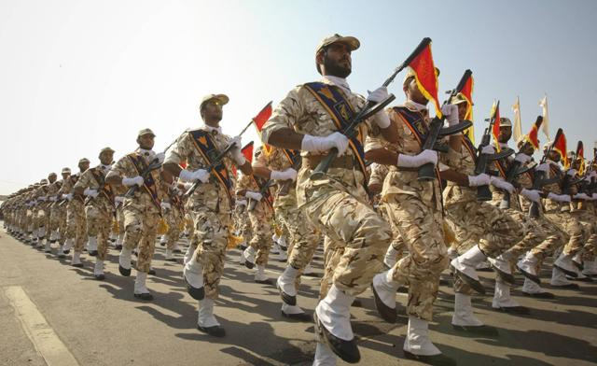



Word Generation Unit 6
Many wars have been fought by America. Some wars are because people believe that military action is the only way to make sure the U.S. is safe. More than 2000 U.S. troops have died trying to make Afghanistan a more _____________ country that does not have terrorists. In 2003, the U.S. went to war in Iraq. They said that the Iraq _____________ had weapons to destroy Americans. These weapons were never found. According to _____________, the cost of this war was $1 TRILLON dollars!!
Some people believe that the U.S. should only go to war to help people from other countries. For example, people in the Darfur region of Sudan were being murdered and forced to leave their villages. 2.7 million African people were _____________. Many Americans thought that the U.S. should have done more to _____________ the suffering of these people.
What do you think? Should the U.S. government send troops to other countries? When is it a good idea? When is it a bad idea?
Unit 6 Answer Key
Many wars have been fought by America. Some wars are because people believe that military action is the only way to make sure the U.S. is safe. More than 2000 U.S. troops have died trying to make Afghanistan a more stable country that does not have terrorists. In 2003, the U.S. went to war in Iraq. They said that the Iraq regime had weapons to destroy Americans. These weapons were never found. According to estimates, the cost of this war was $1 TRILLON dollars!!
Some people believe that the U.S. should only go to war to help people from other countries. For example, people in the Darfur region of Sudan were being murdered and forced to leave their villages. 2.7 million African people were displaced. Many Americans thought that the U.S. should have done more to diminish the suffering of these people.
What do you think? Should the U.S. government send troops to other countries? When is it a good idea? When is it a bad idea?

